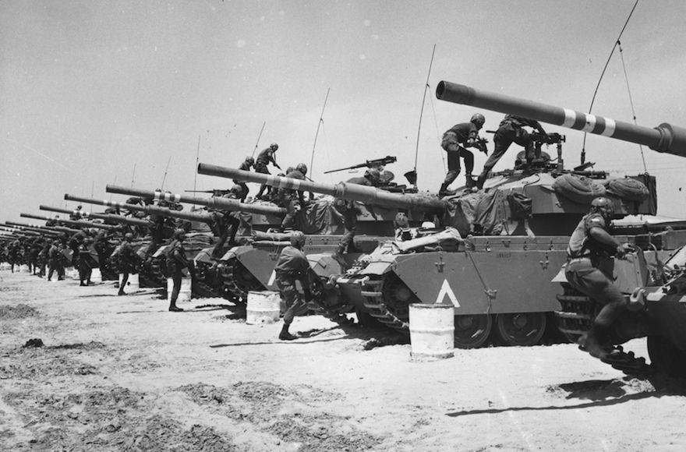

War of the middle east

A song of stats and data

Eli Hundia

By Eli Hundia – I.D. 037028636

Data Visualization course, MSC, Haifa university

Dr. Peter Bak

2.9.2017

table of contents

Introduction 3

The data – The "What stage" 4

Background 4

Format 4

Usage manner 4

The reason – "Why" the data is an interesting one 5

General user task: How do wars in the middle east effect economy of a country in the region? 5

Specific user task: Discover how wars effects High-technology exports in the 20th century 5

User task 1 5

User task 2 5

General user task: How do wars in the middle east effect the population of a country in the region? 5

User task 3 5

General user task: How do wars in the middle east effect the military financially? 6

User task 4 6

General user task: How do wars in the middle east effect the education and science? 6

User task 5 6

General user task: Enjoy exploring data from different times in correlation to dates of wars. 6

User task 6 6

User task 7 6

A story about a server and a browser – "How" to represent our cool data 7

The server 7

The browser 7

Visualization of choice 8

Special visualization features 9

Hide and show countries that the user is interested / not interested in 9

Zooming in and out on specific years 10

Show Y Axis values for a specific year for all countries at the same time 11

The engines under the visualization’s hood 11

Timeline.js by ilkeryilmaz - https://github.com/ilkeryilmaz/timelinejs 11

Bootstrap – the famous standard library for responsive website 12

C3Js 12

Animate.css - https://daneden.github.io/animate.css/ 12

Cutting to the chase, Example visualizations for the user tasks and their evaluations 13

User task 1 13

User task 2 14

User task 3 15

User task 4 15

User task 5 18

User task 6 19

User task 7 21

How to make it work – Set up instructions 22

System interfaces 22

Set up instructions 22

Running the server 22

Running the website user interface 22

Project structure 22

Conclusion 23

# Introduction

The project is about a range of different stats and data over the years about Israel and its tier-1 neighbors, Joran, Egypt, Lebanon and the Palestinian authority.

The project focuses the times of wars between the countries, several years before and after each war in hope to see how a war has influenced the countries involved in different aspects such as population stats, financial stats, education and military.

I believe that presenting the raw data collected, in an aspect of how the past wars in the middle east had affected the fighting countries and the region in a scope of before and after each war, can be an extremely useful tool for researchers from different fields, fields like economics, history, social researchers and more that wish to study the effects of wars on their fields of research.

# The data – The "What stage"

## Background

The source for all the data was the "World bank of data", <https://data.worldbank.org/>, in which I extracted a subset of data for the countries mentioned above. I Also relied on Wikipedia for a general description of each war.

The data gathered is a subset of a larger data about countries worldwide, Data that is categories over 1506 different categories about a variety of different interests and topics such a population, economics, education and much more.

The subset data collected is of the years 1960 to 2016, and for the tier-1 countries surrounding Israel.

## Format

The data itself comes in a CSV format, which is a Table dataset type with items and attributes which are categories and ordered sequentially by years. The values themselves are quantitative.

The dataset has 3 key attributes that play a role in defining the dataset

* The country
* The Type of data called Category
* The value in a given year.

The dataset comes in 3 separate files

1. The primary dataset file contains lines of the following attributes:

* Country name
* Country code
* Category indicator name
* Category Indicator code
* Values for the indicator per year, ranging from 1960 to 2016.

1. A category explanation file, which maps a category to its extended explanation / information about it.
2. A mapping file form the country indicator code to its actual country name. (Unnecessary since in the primary file there is both).

## Usage manner

For convenience, the dataset was converted from CSV files to JSON files to ease of work in JavaScript in which JSON format comes naturally in the language.

The way I treated the data is in a three-dimensional manner where the 3rd dimension is by looking at each year at several countries per category.

# The reason – "Why" the data is an interesting one

The list of questions you can ask about such data is pretty much endless, it can be interesting for different researches in a wide range of research fields to ask different questions.

I have assembled a number of user tasks, from different categories in to ask different types of questions.

## General user task: How do wars in the middle east effect economy of a country in the region?

### Specific user task: Discover how wars effects High-technology exports in the 20th century

#### User task 1

##### Action

Analyze Operation Cast Lead in 2006 effect on High-Tech exports for Israel and the Palestinian authority.

##### Target

Find trends in the high-technology exports for Israel and the Palestinian authority caused in the year of the operation and the years that follow.

#### User task 2

##### Action

Analyze the second intifada in the year 2000 effect on Commercial service exports in Israel and the Palestinian authority.

##### Target

Find trends in the Commercial service exports for Israel and Palestinian authority caused in the year following the intifada.

## General user task: How do wars in the middle east effect the population of a country in the region?

#### User task 3

##### Action

Analyze 1973 Yom Kippur war effect on the annual population growth.

##### Target

Identify outliers on the population growth that may result due to many casualties in the war.

## General user task: How do wars in the middle east effect the military financially?

#### User task 4

##### Action

Query both intifada's and record the data on the year before during and after the intifada.

##### Target

Identify trends and similarities between the two to find if there is a similar effect on the arms import for Israel.

## General user task: How do wars in the middle east effect the education and science?

#### User task 5

##### Action

Analyze the first Lebanon war in 1982 and analyze its effect on the amount of trademark applications registered for Israel and Lebanon.

##### Target

Identify trends in the year before and after the war.

## General user task: Enjoy exploring data from different times in correlation to dates of wars.

#### User task 6

##### Action

Scroll through the different wars, reading general information about each war.

##### Target

Read general information about each war / conflict, who participated and how it concluded to enjoy a good history lesson.

#### User task 7

##### Action

Scroll through the different wars, look at random arbitrary stats from different categories.

##### Target

Get exposed to some interesting stats topics that aren’t necessarily war related, some sort of fun facts for casual people.

# A story about a server and a browser – "How" to represent our cool data

When being asked to display some data on a browser, the first thing that comes in mind is to give an end to end html / JavaScript based solution and be done with it. The right thing to do, when thinking in aspects of fast computation, user experience, scalability and on top of all that believing that what you do might just actually serve several academic "clients" in the future, you must give a high-quality solution.

## The server

I have written a node.js server from scratch, in several layers, that reads the dataset from the JSON created as described in the "What" section into its runtime memory (no consistent MongoDB and some other funky overkills at this solution) using pre-built API's to query the data with ease, while eventually serving as a webserver that allows REST API requests from html web pages on the dataset. The queries are extremely generic in nature, they allow a web browser user to query for a category, under range of years, and for a given list of countries – Maximum flexibility to ask basically whatever query you have in mind. Given a query, the server will run through the entire dataset, gather the information requested, wrap it up in a JSON formatted response and send it back to its origin querying source.

## The browser

I have created a fully functional website, under my personal belief that this website can serve as a tool for researches to investigate the effects of wars on different aspects of our day to day lives. I took the time to build a stable, scalable, dynamic and fast and user-friendly website, in hope that it might serve as a framework or a tool for future academic developments / research that will expand / utilize it to their needs.

I have given as much as though to the user interfaces as I gave the actual data representation. To wonder around different times in history, let alone in different categories in our day to day lives, has to be a simple task for the user or he might get lost in the data. After running though countless ideas and frameworks, I have concluded that a timeline, to iterate over the years is by far the most simple and intuitive user interface to wonder around through the wars. With the timeline, in order provide some basic information about each conflict, I added a brief quotation from Wikipedia, to give the user a brief background to the conflict for which its data he is about to see. Not only traveling through the wars is important, most users will be the academic types and they usually come to query something that interest their field of study. The general categories that comes with the dataset must also be easily navigable, a user the is interested in financial stats and data does not care for the growth percentage of the population and it will be inconvenient for him to scroll through such data instead of being shown the relevant data for his research. So, I added another ability to view groups of information under pre-defined categories the user can choose from. Under each category, you can find plenty of visualized stats and data for different conflicts.

**Example for the overall view of the browser user interface**

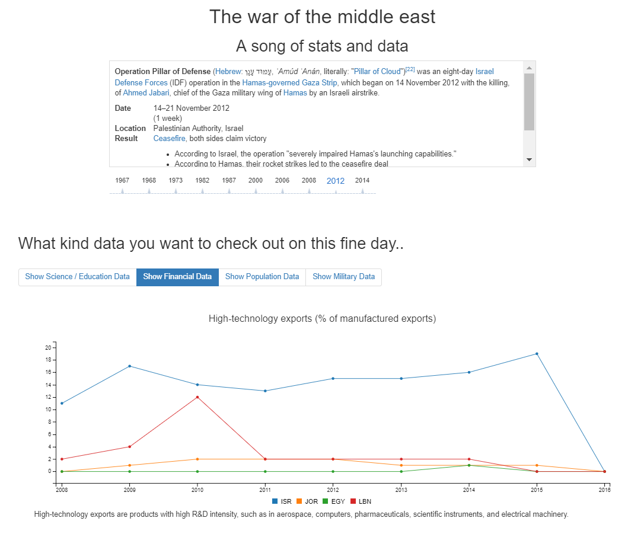

## Visualization of choice

I have tested out many visualization types over the dataset. I have tried pie charts, bar charts and much more before coming to realize that a line chart is the best practice for display the dataset.

A pie chart was ruled out for several reasons, while the main reason Is the fact that it cannot show data over several years. While the all the user tasks I suggested analyze trends over time – years in our case, a pie chart cannot be used to answer such queries.

A Bar chart was also considered, and can still be a good solution when querying for a specific year rather than several years, and due to much learned in the class it will be a much better visualization solution rather than the pie chart visualization. For example, user task 3, can be best answered using a Bar chart since you are being asked not for a trend over years but rather being asked for data on a specific year.

Eventually, the line chart was selected as the visualization for the data on my website, due to its many qualities for presenting data over time in a multi-dimensional manner for several countries simultaneously. With the line chart, comes some extra bonus useful features that help support the user perform his user tasks.

### Special visualization features

#### Hide and show countries that the user is interested / not interested in

The ability to hide countries you are not interested in while making the graph re-draw itself in order to update its scaling to the countries you are interested in and by doing so eliminated background noises distracting the user from focusing on the data he is are interested in researching.

Example for the re-scaling effect when hiding a country

***Before rescaling – Egypt population count exceeds by far the other countries population, not allowing the user a clear view of the population trend.***

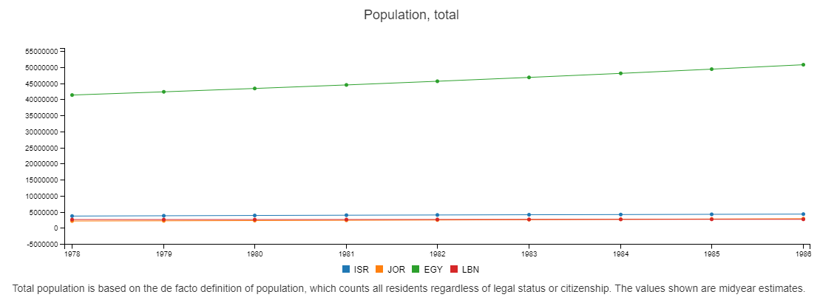

***After rescaling – After selecting to hide the Egypt population line, the graph re-draw’s itself in a new scale, now other countries population can be seen with ease. Notice how the Egypt is greyed out.***

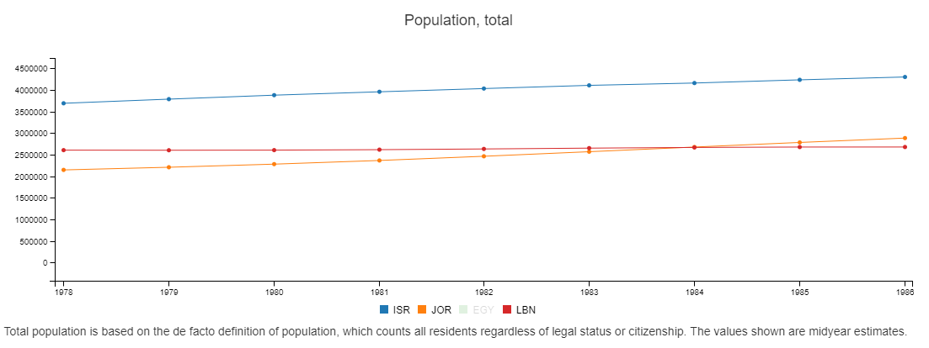

#### Zooming in and out on specific years

Zoom in / out, the ability to zoom in and out on specific years that the user is interested in by a simple mouse to scroll in and out with ease.

Example for the zoom in effect on a specific year’s span

***Before zooming in – the years 2009-2011 has many sharp changes that are mixes up in a big span of years***

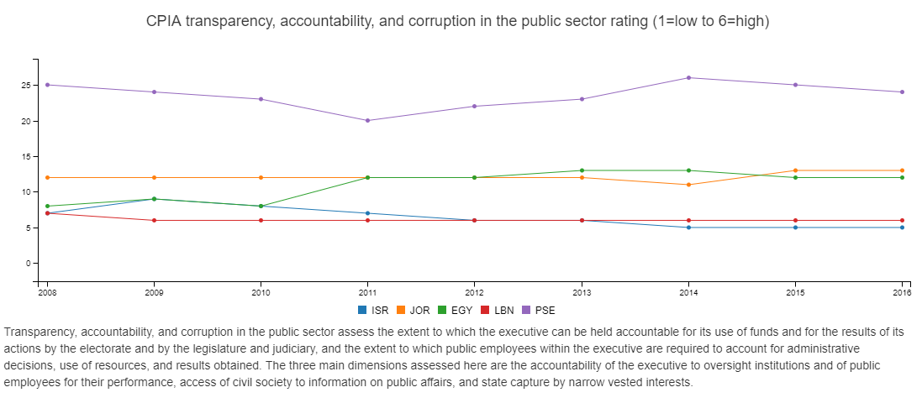

***After zooming in – Now the user can clearly focus on the years he is interested in investigating.***

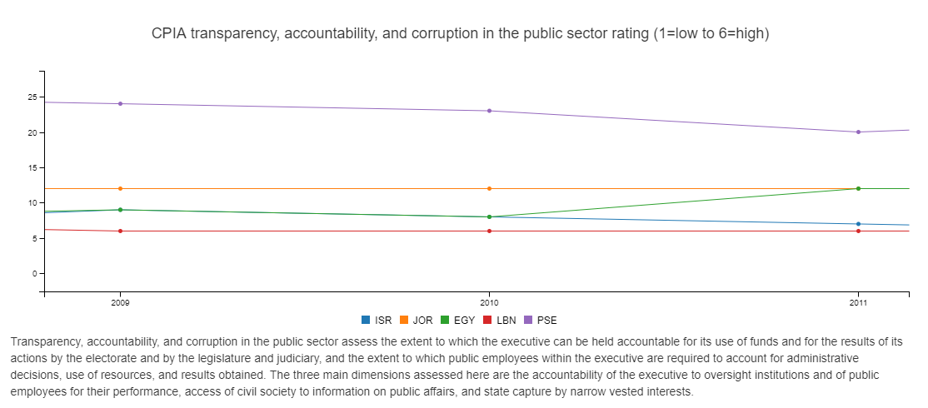

#### Show Y Axis values for a specific year for all countries at the same time

The ability to clearly see Y Axis values for a specific year. This helps out a lot when looking at large sets of data, allowing the user to properly observe and analyze the visualized data.

For example:

Each visualization comes with a detailed description describing the visualization, explaining how the data is formatted, its background and in-depth explanation.

### The engines under the visualization’s hood

#### Timeline.js by ilkeryilmaz - <https://github.com/ilkeryilmaz/timelinejs>

The library offered me the timeline that is used to scroll over the years, allowing also a neat information box for each year. The framework needed some hacking to allow me to respond to the clicks, so I modified the core timeline.js a bit so it will create its years clickable with designated ID for me to listen on.

An example of the timeline from the website

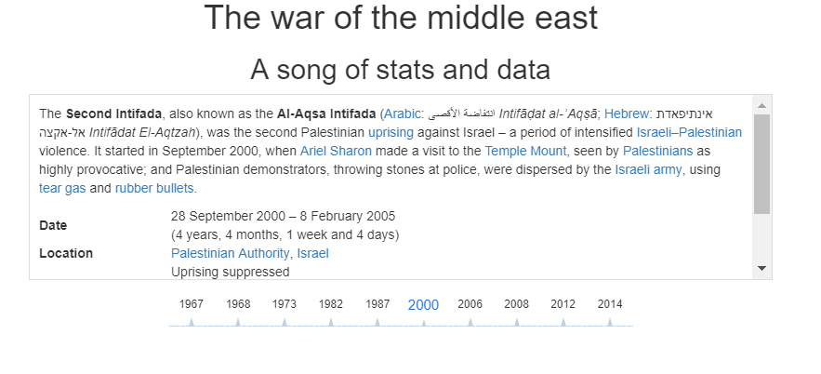

#### Bootstrap – the famous standard library for responsive website

Utilized in order to make the website fully responsive, looks great on mobile, looks even better on a regular browser...!

C3Js – <http://c3js.org/>

A cool library to draw complex graphs, allowing a lot of flexibility to utilize your data.

I tested many visualization libraries, including writing my own graph visualization using D3 from scratch, but as in bootstrap and timeline.js, you can’t beat frameworks that does those things for a living... ☺

I had to create quite a few adapters to prepare the data for the C3 framework, but it paid off and the visualizations you get are awesome.

Using the framework options, I was able to toy around with a large set of visualization capabilities from which I chose the zoom feature, setting the minimum for the Y axis to be at least 0 and allowing a mouse hover a year to get comparison for all the countries values at that specific year.

#### Animate.css - <https://daneden.github.io/animate.css/>

A simple to use CSS based animation library, allowed me to do some neat transition animation when changing the years for example or changing categories, making the graph’s change to move in the direction the years are moving for example. User experience and allowing him to enjoy the visualization is very important...!

### Cutting to the chase, Example visualizations for the user tasks and their evaluations

#### User task 1

The visualization

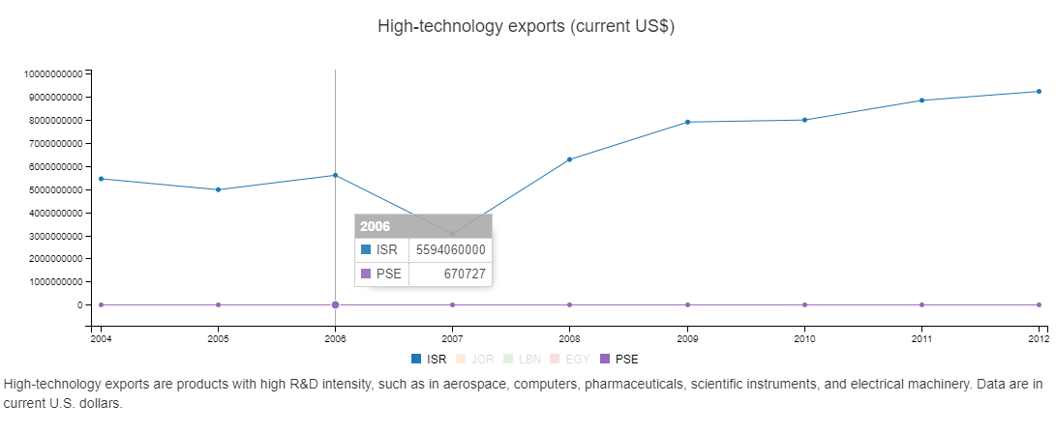

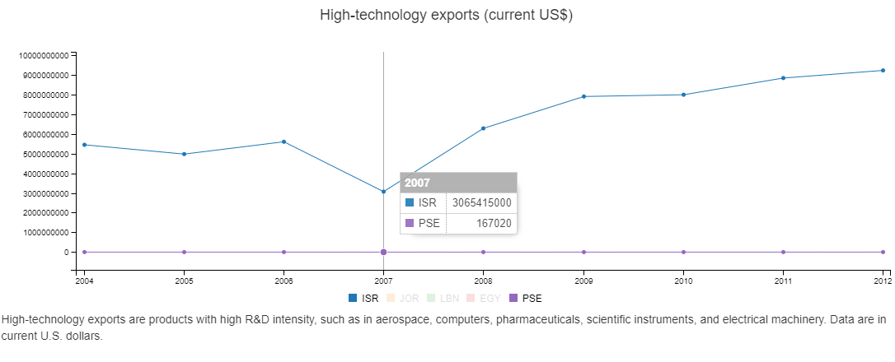

The user target was to find trends in the high-technology exports for Israel and the Palestinian authority caused in the year of the operation and the years that follow.

**The good:** As can be easily observed, the user can observe that the year following the operation suffered a decrease in the high-tech exports for both countries.

**The bad:** The graph does not help understand if for example there was a huge export of military arms for example in that specific year due to a successful proof of arms manufactured in Israel in that operation, which made the high-tech exports seem less significant in that 2007, or in the Palestinian authority a physical destruction of research facilities caused a decrease in the ability to produce high-tech products.

#### User task 2

The visualization

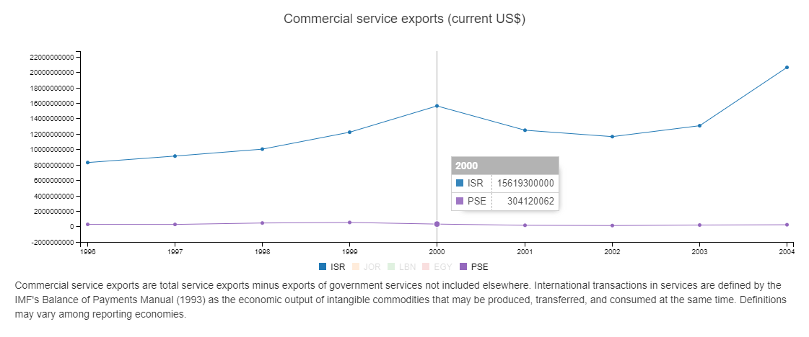

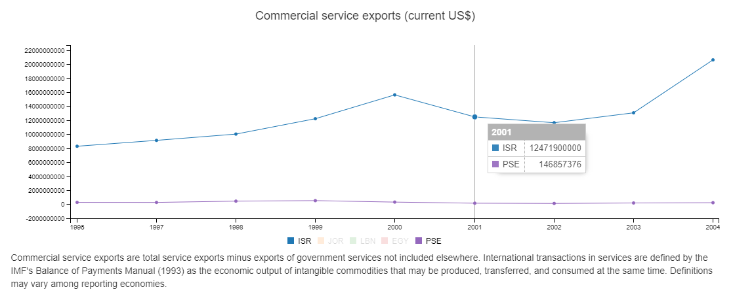

The user target was to find trends in the Commercial service exports for Israel and Palestinian authority caused in the year following the intifada.

**The good:** The user can easily observe that the year following the intifada suffered a decrease in the exports for both Israel and the Palestinian authority.

**The bad:** The graph does not allow to observe trends in the Palestinian authority since its numbers scale factor is much smaller than the Israeli one. Luckily, the user can mask out Israel for that matter, and easily get the following graph for the same year:

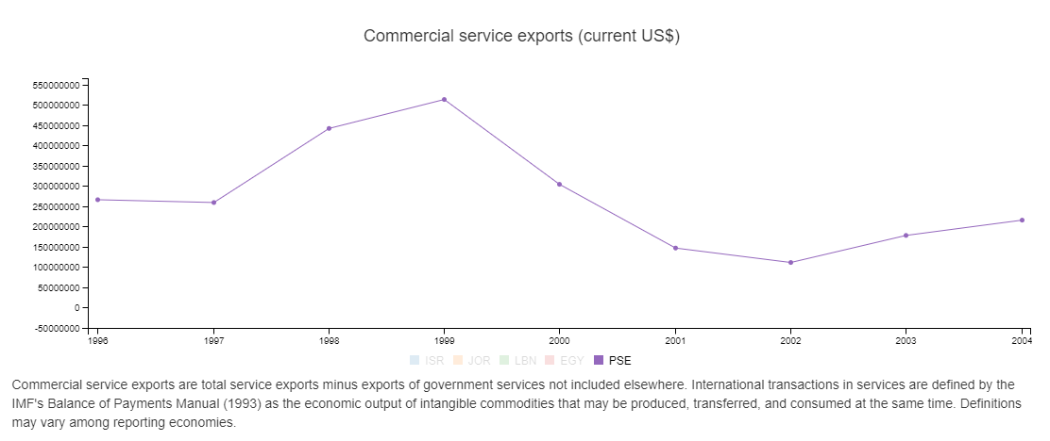

#### User task 3

The visualization

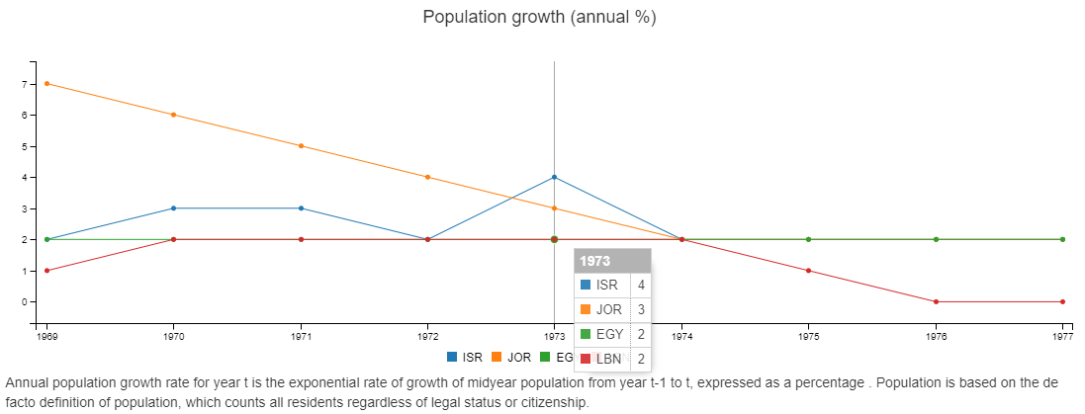

The user target was to Identify outliers on the population growth that may result due to many casualties in the war for Israel and its neighbors.

**The good:** The user can observe that in the year of the war, there was an outlier for Israel population growth rate, peaking at a 4% annual growth rate while the trends for the other countries remained pretty much the same.

**The bad:** When focusing on a specific year, a bar chart in this case might have been more appropriate. That being said, the ability to point at a year and get the individual values for each country adds a dimension that compensate that issue.

#### User task 4

The visualization

The first intifada graphs

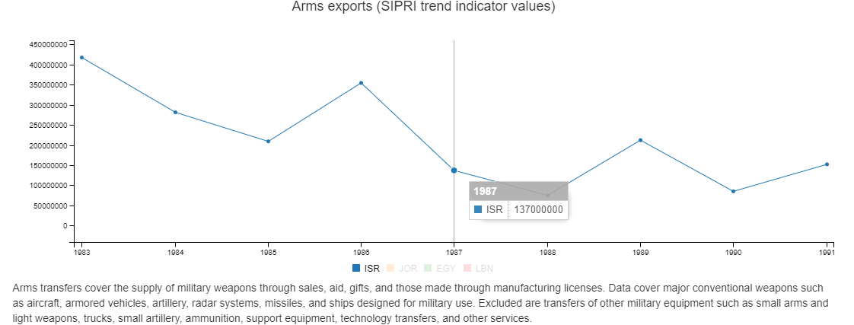

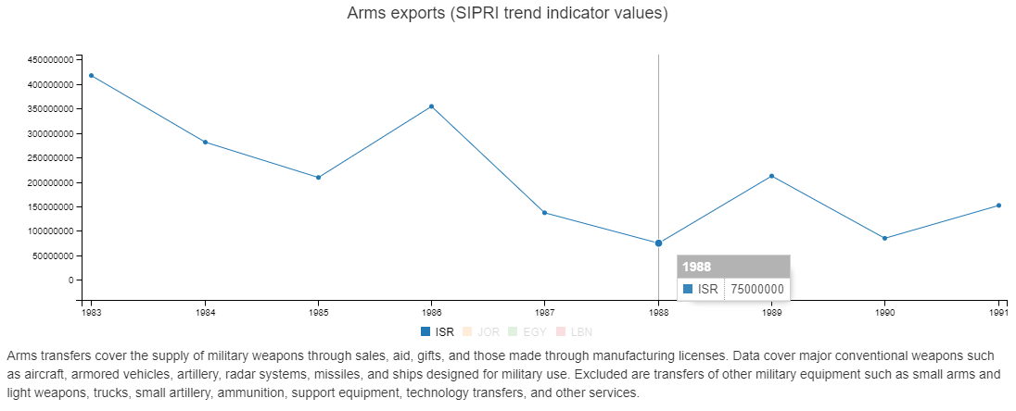

The second intifada graphs

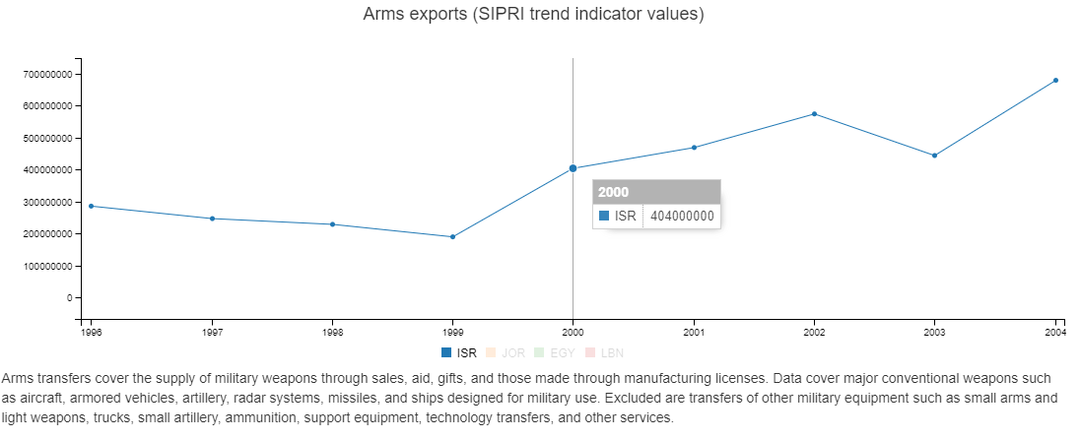

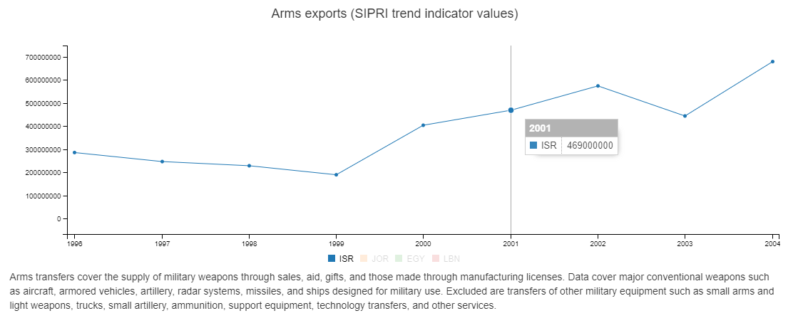

The user target was to Identify trends and similarities between the two intifadas to find if there is an effect of an intifada on the arms import for Israel. Simply put, see if there is a benefit that Israel gains from an intifada for its arm’s export.

**The good:** The user can easily switch between the two intifadas, remaining under the same category. It can be easily observed that the after the first intifada there was a decrease in the exports while in the second intifada there was an increase in the exports. So bad luck for the researcher, his assumption that there is a connection between an intifada to the exports of arms for Israel was not verified.

**The bad:** Might have been nice to offer a visualization that can show a category over the years, rather than forcing the user to scroll between different years for the same category. A possible fix is to allow the user to manually choose his years, and then he will be able to see both years although such a solution is not scalable – What if he will want to compare two years that are extremely distant from one another? he will just get a huge graph of years that is hard to view.

#### User task 5

The visualization

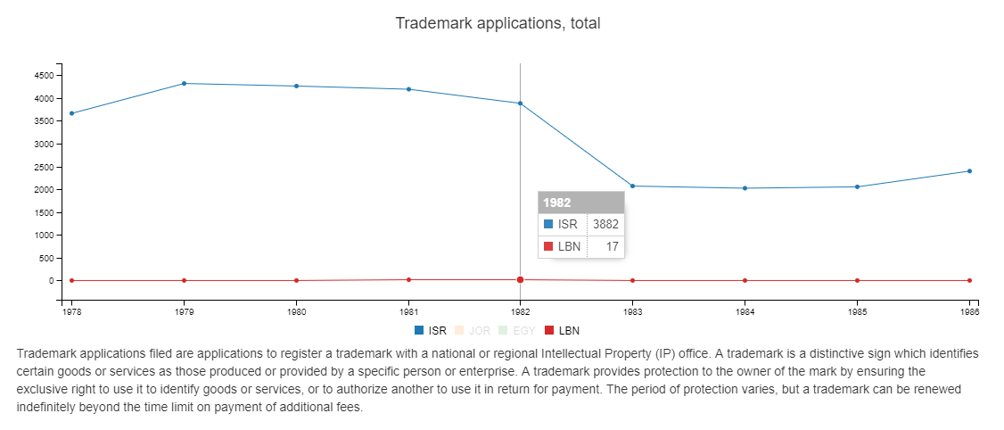

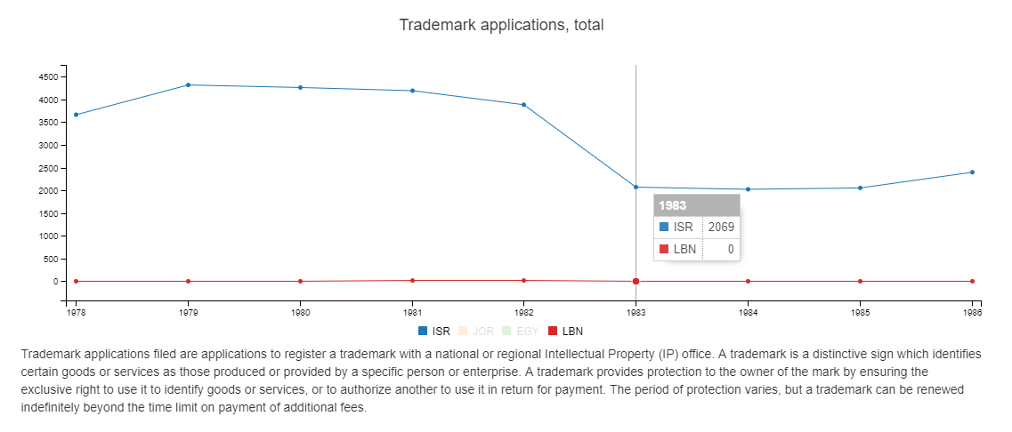

The user target was to Identify trends caused by the first Lebanon war in 1982 and analyze its effect on the amount of trademark applications registered for Israel and Lebanon.

**The good:** The user can observe that both countries suffered from a decrease in the year following the war, while Lebanon stopped creating patents and Israel suffered a major decrease.

**The bad:** The first noticeable thing is that Lebanon during the year before and during the war had a trend of starting to produce trademark applications, that stopped after the war. The trend is missed out in the current view since its scale factor in compare to Israel is small. So, the visualization missed that one out, as can be seen if masking out Israel:

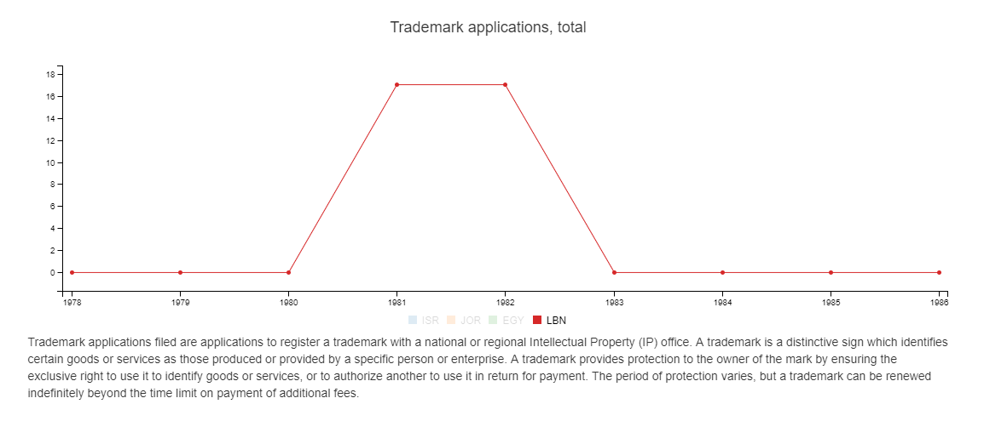

#### User task 6

The visualization

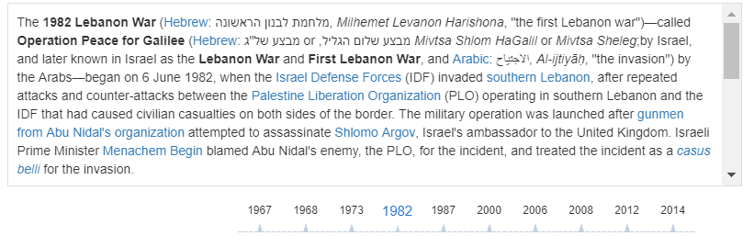 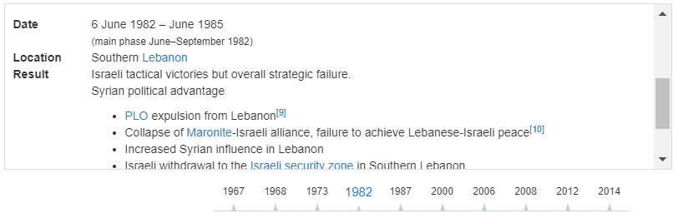 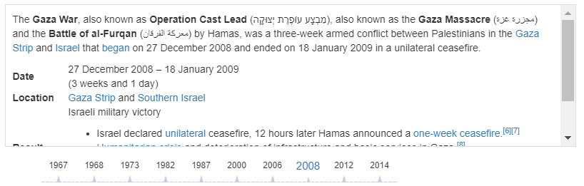

The user target was to Read general information about each war / conflict, who participated and how it concluded to enjoy a good history lesson.

**The good:** The user can scroll with fun and ease threw the wars between Israel and its neighbors, getting general information about the conflict such as background, location and result. Also, most of the text is supplied with links to further read about each place and conflict in Wikipedia.

**The bad:** I had to start out in 1967, the six day’s war, due to an extreme lack of data in the database for the years before that, so I ran some elimination code to parse out the years that were producing empty graph’s.

#### User task 7

The visualization



The user target was to get exposed to some interesting stats topics that aren’t necessarily war related, some sort of fun facts for casual people.

**The good:** Its simply pure fun, wondering around the years and seeing cool data from different aspects of our society.

**The bad:** The project was mainly a proof of concept of sort, an even better in-depth research of the data might have produced more categories classifiers added to the classifiers I created (Financial, Educational, etc…), and as a thoughts for future development it can be a cool addition to add more dimensions to the data such as weather data at the time of a conflict, political databases and much more..

# How to make it work – Set up instructions

## System interfaces

REST API

HTML Web client

Meta Data Dataset

Category API dataset

Country Info dataset

NodeJS Server

Middle East API

Index.js

## Set up instructions

### Running the server

You must have node.js installed on the PC you are running the server on. Once you have Node.js installed, you simply open a shell (Bash or Command prompt) in the folder location “/*NodeInfoServer”* which can be found under the root folder of the project and run the command “*node Index.js*”.

The server will listen on port 5000 by default, feel free to change it to whatever port you see fit.

Once the server starts, it will serve the index.html that can be found under the folder D3Htmls, (a legacy folder name from the start of the course, they never really do change eventually…. ☺) when entering type localost:5000 on the web browser address.

### Running the website user interface

Simply open any web browser once the server is up, type in the address localhost:5000 and you are good to go...!

### Project structure

* Datasets – Original Datasets Used
* SVG – Main folder
  + D3Htmls – Has the index.html, main website page and all of its dependencies – ill specify what’s the important subdirectories you need to know
    - Metadata_indicators – I have put some effort to making the graphs the website present for each category scalable and easy to change. There is a file for each category, in each file there are indicator markers. If you wish to add graph’s to each category, all you need to do is edit these files, appending / removing indicator code’s that can be found under the Dataset indicator and you got more graph’s showing on the website.. ! ☺
  + Node_modules – You can either just use what I downloaded for my node.js server or you can use the package file to redownload everything to your pc.
  + NodeInfoServer – Has the main server node code under index.js, there are extra supporting javascript files were written separately to better test and design the server sub routines.

# Conclusion

The project was a journey, I have learned a lot and enjoyed learning different visualization frameworks and the amazing things you can do with them. My background is being a team leader of embedded c++ group, Web / Servers / Graphic stuff isn’t really something I do on the mainstream and it was a very good experience to get exposed to all the visualization techniques and considerations revolving around creating a good visualization solution. I haven’t used some of the crazy cool D3 example’s I have come across since I could not see how the data that I found might fit there. I considered at some point and even toyed around with a force graph to show the countries and wars but it all seemed like it was all cool but not really useful to present the data I wanted to explore. I am very happy with the result, let’s put it on git, and see if anyone might be interested in using it / further developing it in the future.

I hope you will enjoy the project, I’m pretty sure you would have done everything a whole lot different, I am looking forward for your review.

Good luck and thank you for the course,

Eli Hundia.